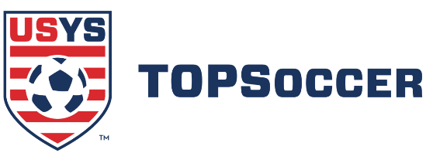

2019 US Youth Soccer TOPSoccer® Buddy of the Year
Nomination Form
Requirements to apply:
An individual may be nominated and selected as the TOPSoccer Buddy of the Year for extraordinary accomplishments as a TOPSoccer Buddy if the individual, in carrying out the US Youth Soccer TOPSoccer program and its events and activities—
(1) has demonstrated patience, understanding, dependability, flexibility, and ability to adjust to ever-changing on-field situations;
(2) has proven to be an invaluable volunteer who facilitates the Program by filling many roles, including being a coach, a cheerleader, a role model, and assisting when needed with administrative responsibilities;
(3) has provided support, engaged players one-on-one, and modeled desired behavior in group play or off to the side of group play; and
(4) is cognizant of player safety while assisting, guiding, directing, teaching the game of soccer and its skills, and creating a fun and learning experience.

State Association:

Complete home address and phone numbers are required. Please TYPE or PRINT LEGIBLY.
Nominee’s Name:
* PRINT nominee’s name EXACTLY as it is to appear on the certificate.
Address:
City: |  |  |  |  | State: |  |  | Zip: |  | Email:
Phone (area code): |  |  |  |  |  | Occupation: |  |  |  | TOPSoccer Program:

Criteria:
Reponses to each of the following 3 criterions should be kept to a maximum of 400 words and attached on a separate sheet.

1) Involvement with TOPSoccer and community:
How and when did the nominated Buddy get involved with TOPSoccer? What impact has he or she had on the local association? Has the TOPSoccer Buddy demonstrated leadership within the community? How so? What other activities is the Buddy involved in?

2) Promoting the game:
What steps has the TOPSoccer Buddy taken to further advance the game and all who participate? Does the TOPSoccer Buddy participate in soccer outside his or her position as a TOPSoccer Buddy (i.e. playing or refereeing)? Has the Buddy created relationships within the community to promote the game? Give examples.

3) Moral and Ethical Character:
Does the TOPSoccer Buddy share similar values to those of US Youth Soccer and its’ members? Has the TOPSoccer Buddy received compensation for his/her efforts? How has the TOPSoccer Buddy’s involvement with TOPSoccer shaped his/her character?

Nominator Name: |  |  | Relation to Nominee:
Phone (area code): |  |  | Email:
Address: |  |  | City: |  |  |  | State: |  | Zip:

Entries for state consideration should be mailed to your State Association office. Deadlines vary, so please check with your State Association office. Their contact information can be found by clicking on the link below:

www.usyouthsoccer.org/aboutus/StateAssociationDirectory.asp

Your completed nomination should include only the a) completed nomination form & b) supporting documents. No more than 3 letters of recommendation should be included. Others will be discarded. The winners of each of the 55 State Associations will be forwarded for regional nomination and possible national nomination as the 2018 US Youth Soccer TOPSoccer Buddy of the Year.

Subject to change

